Newsletter Article - Small Acts … Big Differences
Like all schools, we’ve been looking at budgets and trying to work out how to reduce costs. Working with our cleaning company, Nviro, we are making some changes which will see us saving money and hopefully result in a more hygienic environment for us all to work in.
Nviro is a specialist cleaning and hygiene business with a focus on people. Their mission is to create spaces where people can be their best, whilst building a culture that allows people to thrive. This means their top concern is in keeping our students and staff healthy and safe.
From <insert date>, we are going to start using an anti-microbial protective coating to kill bacteria, viruses and germs on many of our surfaces. As a water-based solution, the coating is non-irritant and odourless. We’ll be spraying this every half-term to make sure it keeps on working.
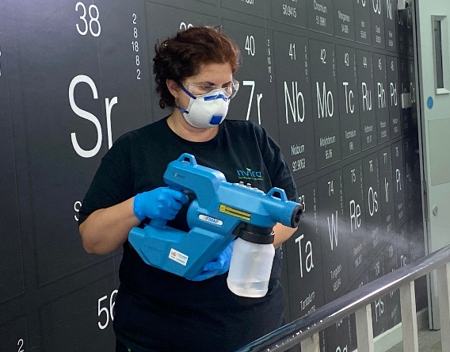
It works like this:
To check its impact, the Nviro team will carry out regular swab tests on key touchpoints. These should show that bacteria, viruses and germs are being killed off – keeping our students safe. New measures should mean a reduction in sickness, and any winter flu and vomiting bugs won’t have such a big impact.
On top of that, we’re going to be using surface-enhancing sprays to protect surfaces – such as tables, doors, and handrails. This will make it easier to clean, reducing the time it takes for the cleaners to remove marks and stains and reducing costs.
We’re also asking everyone in the school community to use centralised bins and not leave rubbish lying around. To flush toilets and put paper towels in bins. School staff will be asked to wash up their own crockery – or at least put it in the dishwasher – and leave floors as clear as possible, so we can try out some robot vacuum cleaners.
However, we’re also going to reduce the amount of cleaning in some of our quieter areas each week. This means that offices, meeting rooms and some carpets may not be cleaned every night but will be tackled when needed.
These measures are being implemented in many schools and we’ll be monitoring them to make sure that school remains a clean, hygienic and safe place to be where students can thrive and fulfil their potential.
If you would like to understand more about what we are doing, please visit www.nviro.co.uk/school-cleaning/

